Widening the World
by way of Considering the Contrary Poles
between Contour Line and Domain
VIPSI TIVAT 2011.12.31 MOTOYA Yoshiko
y-motoya@osakajyosi.ac.jp y-motoya@i.softbank.jp

Key word - two poles, creative expressions, conception of space, sharing, relation between two domains, contour line

Abstract - To consider our theme, we adopt first "The Scroll about The Tale of Genji" and "Picasso’s Guernica" and "Kids’ Guernica". By comparing these pictures and mural paintings, we can get some new standpoint about the character of contrary poles.
Then we take up The Works of Sessyu and Jakucyu, to get some hints to clarify the relation between domain and contour line.
And then, we consider the drawings of children to find the feature which characterizes the method of understanding by children about the share relation of two domains .
We will see a new world spreads in our heart, through the encounter with these three subjects.

The Picture Scroll and Mural Painting

It is interesting that a mural painting or a picture scroll can show contrary world, such as two times and opposite places in the same one picture.
In Europe, Christ's lifetime was drawn on the wall of many churches for those who cannot read. And we can see picture scrolls or mural paintings of Gautama Buddha's whole life in many temples in Japan.
In case "The Scrolls about the Tale of Genji" (1001), many contrasts between Genji and Ladies, luxury and grief, past and now are effectively drawn with explanatory notes and dialogues.
" The Wildlife Cartoon Figure" ( 1150 ), drawn by Toba bishop, is called as the prototype of Japanese anime and comics. In this cartoon, we can find many secrets of the contrary character of things.
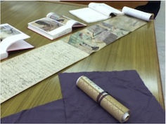
Fig.1 "The Scrolls about the Tale of Genji" (1001)

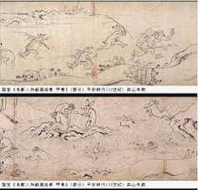
Fig. 2 " The Wildlife Cartoon Figure" ( 1150 )

Kids’ Guernica

Kids' Guernica is an international children's art project to represent the images of peace, on the same scale canvas as Picasso's "Guernica" (3.5m x 7.8m). Pablo Picasso drew "Guernica" to protest against the destruction and brutality in the Spanish civil war in 1937.
20-years-old students drew Kids’ Guernica. They drew their own valuables, and something important among the group. They all think of the tragedy of the great earthquake at 3.11. And they drew to represent what they received from the disaster.

In Japan, we all have suffered by the earthquake, tsunami, and a nuclear power plant disaster, and although the situation is not still settled, we don’t lose our wishes and ends.
The power of human being to overcome the difficulties is large.
They drew it, having their own thoughts to their futures, and considering what they should do.
They drew their own thought about the "desires for peace", just by drawing not only bright futures but sufferings and despairs.
So, they drew ‘Antinomies’, such as the past and the future, light and dark, the upper and the bottom, disappointment and hope, life and death, war and peace, annihilation and revival reconstruction, and man made disaster and natural disaster.
I would like to tell children that in our life it is important to find these contrary poles for themselves.

(Seeing) The bottom of the picture represents the despair of war, poverty and the whole suffering world. Upwards it gradually shows the image of peace and happiness, and we understand that peace will certainly come if we don’t throw our hope away. Many people live in both the opposite world, and they all have the right to get their own future and fortune.

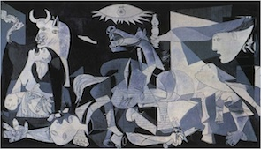
Fig. 3 Picasso's "Guernica" (3.5m x 7.8m)
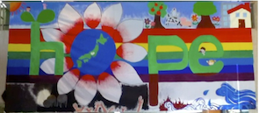
Fig. 4 Kids’ Guernica drawn by 20-years-old students

Contour line and Domain
Pictures and mural paintings are expressed in contour lines and domains. The contour line and the domain are poles. Since a contour line is made automatically between two domains, we can say that a picture is expressed by contrary domains.
Let’s see the characteristics in the famous pictures expressing the relation of domain and contour line.

Sesshuu (1420-1506) (87)
Fig. 5 "Landscape painting (Hougyokukann)" shows the contrast of domains.
Fig. 6 The white domain of this crane, one of the "flowers-and-birds figures”, is left behind after the drawing of an outer domain.
The monochrome painting drawn by sumi (Japanese ink) eliminates feelings by denying all colors, and suggests that we live at once in two world.
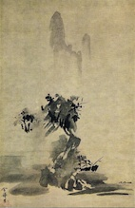
Fig. 5 Sesshuu’s "Landscape painting (Hougyokukann)"

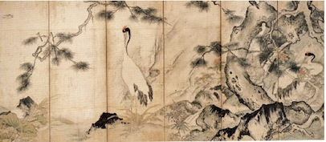
Fig. 6 Sesshuu’s one of the "flowers-and-birds figures”

Jakuchu (1716-1800) (84)
A chrysanthemum Fig. 7 and a hen Fig. 8 .
This white contour line is a special domain drawn by sumi. Sumi gets dry and looks as if a white line, and so the white contour lines of the feather of a hen, or the basho leaf look as if they are drawn by white ink, and it shows effectively the miracle of reversal.

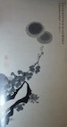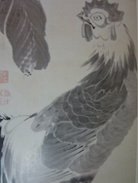
Fig. 7 Jakuchu’s “A chrysanthemum” Fig. 8 “A hen”

Children represents their thinking by drawing
Children must learn the way of recognition to represent their thoughts. There are various failures and difficulties for children to get proper recognition about the domain and contour line. This recognition is indispensable for them to express their thought. What is required for children to understand the share relation of two domains ?
1) Fig.9
What kind of difficulty do children meet during the drawing of domains and contour lines? What did a child want to represent in the drawing Fig. 9 ? Why is it difficult for him to draw them ?
The point of this problem lies in the understanding of the opening and the closing of a contour line. In this case, the contour line is open, so the result is that the whole screen is painted red. The white cravice is left unpainted, so the red sun in the Japanese flag has overflowed from the break of a contour line rapidly. So, he has already understood that if the contour line does not closed, it turns out the whole screen remains as one continued domain.
2) Fig. 10
What does this child want to carry out in his drawing ? (Fig 10 Apple)
The contour line is opened in the left figure ( Fig. 10-1), and it is closed with the right figure. ( Fig. 10-1) The small domain in the middle of the left is painted over. And the domain is protruded (Fig. 10-2). The right figure is also the same. Why did he stoped painting here?
3) Fig. 11
This child is not competent with the contour line of the outer frame of a frog. He can not understand the difference between the contour line dividing the domains in and out of the frog, and that of the boundary of two domains.
4) Fig. 12
The relation between three domains. The left is drawn with a crayon. And the right is drawn with paints. The latter, inside and outside are reverse.
The yolk of an egg is drawn outside, and white and yellow paints have been mixed. But the reason of the mixture does not lie in the difference of the material.
In both cases, the result is the same, if the recognition of the relation of contour line and domain does not change.

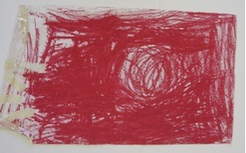
Fig. 9
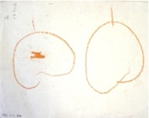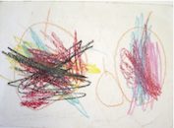
Fig. 10-1 Fig. 10-2

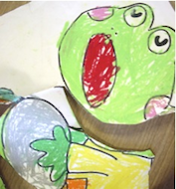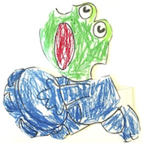
Fig. 11-1 Fig. 11-2

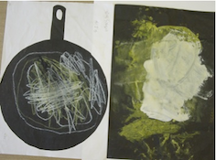
Fig. 12

Share
The difficulty of drawing a fried egg by children lies in the cognition of the share relation between two or more domains. We take out the case of the drawing ‘Hair and face’.
How children draw from Fig. 13-1 to Fig. 13-2 .

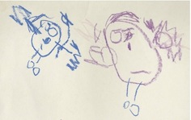 Fig. 13-1
↓
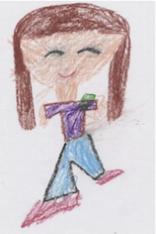 Fig. 13-2
We will pay attention to Fig. 14-1and Fig. 14-2.
Many drawings by 4 years-old children appear like Fig. 14-1. They draw a ribbon on the model, while the model does not attach the ribbon. Why do they not draw hair instead of a ribbon ? Although the model is a woman (in Fig. 14-2), why do they draw it as a male with chin whiskers?
We will consider the problem, what should children think so as to understand the relation between two domains. For them, it is not easy to find the contour line sharing two domains.

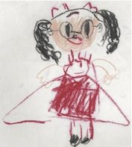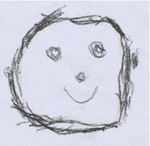
Fig. 14-1 Fig. 14-2

Children can progress his power by considering two poles, comparing, distinguishing and choosing the right thing from the wrong. He can accomplish his problem, even if he is not installed from the teacher, and if he notices the pole character in every things.

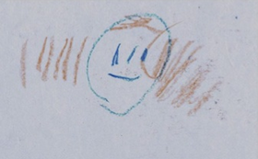 Fig. 14-3
Separating and touching
↓
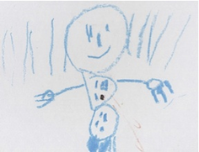 Fig. 14-4
Sharing point

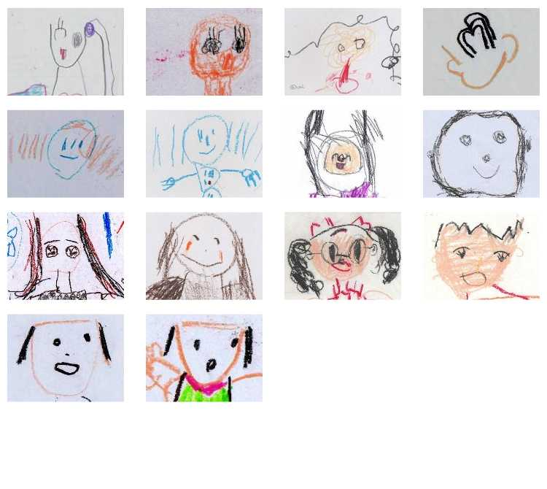Fig. 15

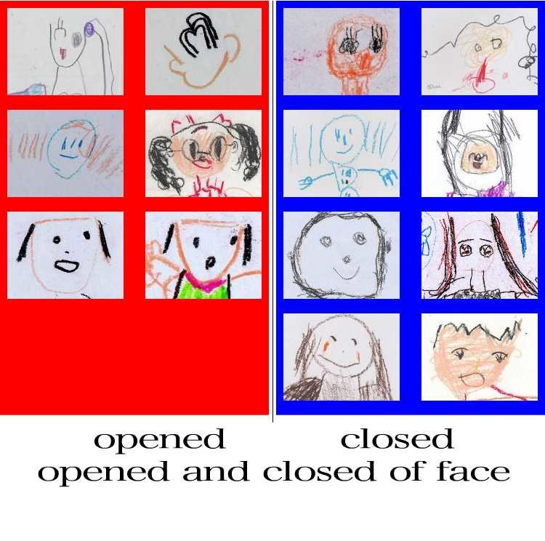 Fig. 16

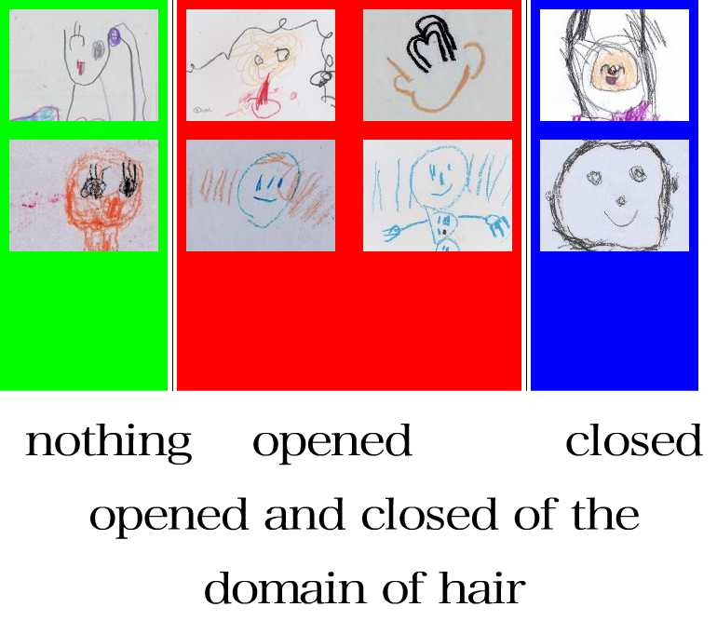 Fig. 17

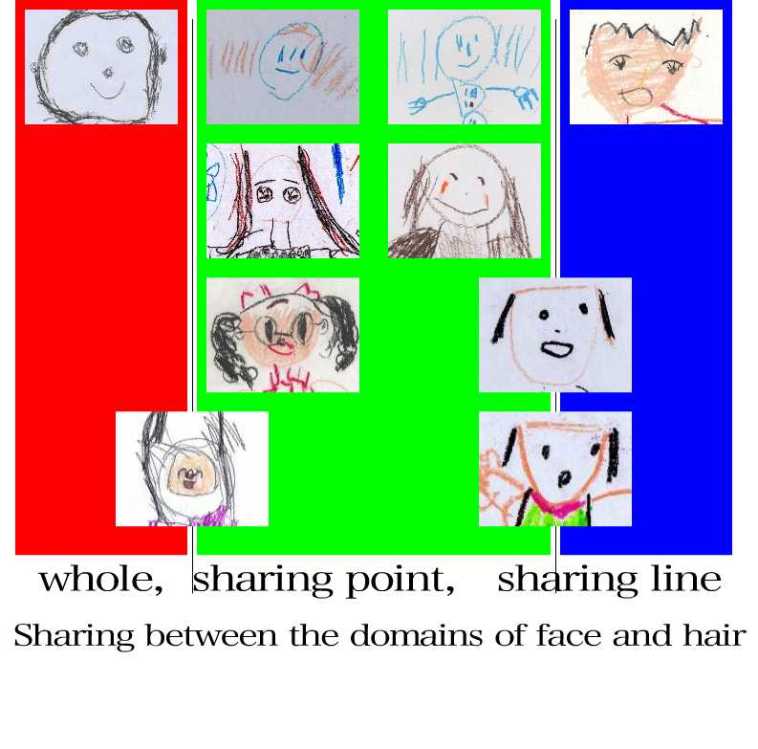 Fig. 18

Conclusion
Comparing the drawings by children and adult, applying pictures by children, mural paintings and a picture scroll by artist or students, we can tell the importance to discover the pole character of contour line and domain.
Mural paintings and picture scrolls, such as the Tale of Genji, Picasso's Guernica, and Kids’ Guernica, show the secret of contrary character of the poles in contour line and domain.
The author of The Scroll of Tale of Genji, Sesshu and Jakuchu, the three excellent Japanese artists, show us the miracle of poles, applying the method of expression of contour line and domain.
Students tried to express the gradual transference from the bottom world to upper world, the past and the future, light and dark, poverty and wealth, life and death. They considered human relations between themselves or surrounding people, and expanded expressional width in mural painting work.

And as for the drawings by children, there we find various failures and difficulties in gaining recognition of domain and contour line. And if they pursue their possibilities of conquering failures by themselves, considering various two poles and the share relation between two domains.

 

